Project Identification Fic he
CUG 1065 (Uganda)

Water supply to the rural district ofIsingiro and its refugee camps

AFD sovereign loan of €52 million, AFD grant of €2 million, and management of an EU-delegated grant of €8 million

TABLE OF CONTENTS

GLOSSARY OF ACRONYMS USED 3
Identification of project 4
I - the sector and the issues 4
1.1 - Presentation of Sector 4
1.2 - Government Policy 4
1.3 -Importance to the country 5
II - project 5
2.1 -Objectives 5
2.2 - Content of the project 6
2.3 - Financial viability of the project 7
2.4 - Stakeholders and procedure 7
III - LE BENEFICIARY 8
IV - Expected outputs, results and impacts of the project 9
4.1 - Contribution of the project to sustainable development issues 9
4.2 - Consistency with the climate strategy 10
4.3 - Monitoring and evaluation and indicators 10
4.3.1 - Monitoring and evaluation system 10
4.3.2 - AFD Accountability Indicators 11
4.4 -Strategic coherence and contribution to French economic influence 11
V - Risk assessment 12
5.1 -Country Risk 12
5.2 -Technical risks 13
5.3 - Institutional and legal risks 13
5.4 - Environmental and social risks 14
VI - Financing of project 15
6.1 - Cost and financing plan 15
6.2 -Justification of the AFD financial product, subsidiarity, terms ...... 16
6.3 - Rationale for using delegated funding 16
6.4 - Main conditions precedent and commitments 16
VII - Provisional timetable for instruction 16
VIII - CLASSIFICATION e&S, hierarchy, other actors and means to be mobilised 17
8.1 - Environmental and social ranking 17
8.2 -Project management structure 17
8.3 - Means to be mobilized 17

Appendix 1 – Location of project 18
Annex 2 – WATER AND SANITATION INDICATORS OF TARGET DISTRICT 19
Annex 3 – TECHNICAL REFERENCES OF THE COUNTERPARTY 20
Annex 4 – PROPOSAL FOR EVALUATION TERMS OF REFERENCE 21

COMPOSITION OF THE PROJECT TEAM

function | name | Department/Division
Regional and Geographical Coordinator | Frederic MINARET | Afr
Agency Project Manager | Juliet ABALIWANO | AFD KAMPALA
Project Team Leader | Bertrand CLOCHARD | EAA
Environmental and Social Expert | Jérémie DULIOUST | aes
Crisis and Conflict Expert | Nelly RELIAT | Ccc
Expert On Delegated Financing | Quentin LAJUS | Sfm
Expert Knowledge of the Counterparty | Florence MARZUK | crc
Expert Procurement | Benoit CHASSATTE | apm
jurist | Youssouf SYLLA | Jur

GLOSSARY OF ACRONYMS USED

ANO Notice of No Objection
AMO Project management assistance
ODA Official development assistance
AT Technical Assistance
EIBEuropean Investment Bank
CIS Sectoral intervention framework
DEA Directorate of Environmental Affairs
DWD Directorate of Water Development
DWRM Directorate of Water Resource Management
EIESE Environmental and Social Impact Study
FERCSed and Capacity Building Funds
IMFInter-Monetary Fund
HDI Human Development Index
IWA International Water Association
JMP Joint Monitoring Program
JWSSPS Joint Water and Sanitation Sector Program Support
LV WatSan Lake Victoria Water and Sanitation Project
LRA Lord's Resistance Army
MoWE Ministry of Water and Environment
MoFPED Ministry of Finance, Planning and Economic Development
NEMA National Environment Management Authority
NDP National Development Plan
NRWNon Revenue Water
NWSC National Water and Sewerage Corporation
SDGsSustainable Development Goals
NGOsNon-Governmental Organization
PAR Reinstallation Action Plan
GGP Environmental and Social Management Plan
LDC Least developed countries
GDPProduced domestic product
UBoS Uganda Bureau of Statistics
PMU Project Management Unit
Ugandan Shilling UGX
UNHCR United Nation High Commissioner for Refugees
UoWSUmbrella of Water and Sanitation
WTPWater Treatment Plant
WSDFsWater and Sanitation Development Facilities

IDENTIFICATION OF THE PROJECT

the sector and the issues

Industry Overview
General information about the country
Ugandalies north of Lake Victoria,for nearly 242 km^{2.} Its population of 39 million inhabitants, 74% of whom live in rural areas, is growing by 3% a year. In addition to these inhabitants, nearly 1.2 million displaced persons have come fromCongo, Sudan and Burundi, which makesUganda the leading country in Africa toreceive refugees.
Organization of the water sector
For the purpose of the organizationof the water service, the Ministry of Water and Environment (MWE), which oversees the sector, has divided ugandanterritory into 4 subsets:
- in the 250 or so largest localities, with a population of 14 million (37% of thepopulation),the water service and the management of related investments have been entrusted to the public operator National Water and Sewerage Corporation (NWSC);

- In the 250 or so smaller localities equipped witha distributionnetwork,which havenearly5 million inhabitants (13% ofthe population),the water service is the responsibility of one ofthe 6 Umbrella Authorities (UA), regional organizationsthat link the territory. Eachof these DU is backed by a Water Supply Development Facility for the conduct of investments;

- in refugee-hosting areas, water services are the responsibility of the Office of the United Nations High Commissioner for Refugees (UNHCR), under the supervision of the Office of the Prime Minister (OPM);

- in the rest of the country (50% of the population), and under the Local Government Act 2000, responsibility for water services is vested in local district authorities, under the supervision of the Ministry of Water and Environment. Thedistrict authorities receivegrants for investment. Once the new infrastructures have been built,they frequently entrust their management to local organisations, often community-based organisations, or to small private operators.

Sector performance
From a technicalpoint of view, the sectoral indicators are satisfactory. In urban areas, therate of access to water as defined by the WHO Joint Monitoring Programme is 77%,andcould reach90% in 20-25. In rural areas, it is 70%, while the rate of functional water points is high, at 85%. As is often the case in this area, however, these average values mask large disparities.
From a financial point of view, thetariffs and commercial performanceof the variousoperators make it possible to cover the operating costs (operation and maintenance) of the water service. The heavy investments needed to develop the sector, on the other hand, are still dependent ongovernment grantsandinternational aid.

Government policy
Since 1997, the Government has undertaken a reform of the water sector based on the withdrawal of the Stateas operator, and thegradualachievement of a rate of access to drinking water of 100%, with specific terms of service and tariff for the poorest.
The implementation of this strategy has received the support of many donors, including the World Bank, the EuropeanUnion, the African Development Bank, Germany, Denmark, Japan, the Netherlands, and Austria. They have signed the Joint Water and Sanitation Sector Programme Support (JWSSPS) with the Government for the period 2008-2012, and then for theperiod2013-2018, while a new programme is being formulated.
In line with thisstrategy, theG-Ouvernement has promoted the development of the national champion, the public operator NWSC. It also massively subsidizes investments in the watersector, to thetune of 3%of the national budget. Loans granted to Uganda by international financial institutions to develop urban water infrastructure are thus systematically returned as a grant to the operator NWSC.
At the same time, the Government has undertaken toprofessionally exploit these same infrastructure,by pooling technical expertise and pooling it on a regional or national scale. Thus,building on NWSC's recognized know-how, it gradually expanded its mandatefrom 1,10cities in June 2015 to 236 cities two years later.
Thus also, in July 2017 it reformulated the mandate of the six Umbrella Authorities, to give them full responsibility for the water service ofsmalltowns.
In refugee-hosting areas, the Government is exploring the possibility of NWSC gradually replacing UNHCR, which wishes to disengage from the water service.
In the rest of the country, where nearly 50% of the populationresides, the establishment ofa nationaloperator is under consideration.

Importance to the country
The country has a substantial rainfallof almost 1 000 mm/year on average. But the continued growth of the population leads mechanically to a decrease in the amount of water available per capita. Uganda will thus join from 2020 theso-called "water-stressed" countries (less than 1,000 m³/inhabitant/year).
Although this strain on water resources is not yet having an impact,thevarious Ugandan governments that have succeeded each other over the past 20 years have all considered the issue of access to water to be strategic,and have madethevery important financialeffortsalreadymentioned.
The results obtained are commensurate with these investments. The access rate has increased considerably despite strong population growth,while the NWSC operator has become a global reference.
However, significant efforts remain to be made in rural and peri-urban areas to make the water service truly inclusive.
Similarly, in the context of the risks of a pandemic in the Great Lakes region, and at the same time rapid urban growth in Uganda as in the rest ofAfrica,the development of urban sanitation must also be the subject of greaterefforts.

the project

Objectives
The finality of the project is to improve the health and living capacity of the inhabitants of the rural district of Isingiro, located on the Tanzanian border in the south-west of the country, with a population of 550,000, including 110,000 refugees. The rate of access to water (37%) it is twice as low as the average rate in rural areas. Nearly 35,000 inhabitants of the district of all origins are expected to benefit directly from the project, the joint service of Ugandan so-called host populations and refugee populations constituting the particularity. This particularity has attracted the attention of the European Union, which wishes to finance through the Investment Programme for Africa (AIP) the part of the project located in areas hosting refugees.
The specific objectives of the project are:
- increasing the rate of access to water for ugandan people in the district;
- improving the conditions of access to water for refugee populations in the district;
- improved sanitation;
- strengthening the sustainability of local water resources management;
- capacity building of local stakeholders.

Content of the project
The project is an extension of the CUG 1051 project approved by the AFD Board of Directors in December 2016, which includes water supply to the large city of Mbarara in the north of the Isingiro district via a supply through the same district.
In the interests of social ties, the Government wished to use the potential of this new supply to improve the water supply to the district through which it is used. The final beneficiaries will be Ugandan populations and refugee populations, in accordance with the REHOPE (Refugees and Host population Empowerment) policy adopted by the Ugandan Government, and in a humanitarian-development nexus approach.
The project thus includes works and accompanying measures to be carried out both in rural areas and in two refugee reception areas, the camps of Nakivale and Orushinga.

The work is conventional and involves the installation of distribution pipes from the main supply, and the construction of small associated structures (pumping station, reservoirs, hydrants). The accompanying measures cover the development of non-collective sanitation, the management of water resources, capacity building of local stakeholders, as well as specific actions in the two refugee camps. All interventions are divided into 4 components:

Component 1-A: water supply works in isingiro district, excluding refugee camps
- Installation of about 220 km of pipes DN 110 to 300;
- Construction of 10 reservoirs of capacité 200 to 1000 m^{3;}
- Installation of 500 to 1,000 hydrants.

Component 1-B: engineering works in the Isingiro district, part of the refugee camps
- Laying of approximately 20 km of pipes DN 110 to 200;
- Construction of 5 tanks with capacity 200 to 1000 m^{3;}
- Installation of 250 to 500 pre-payment hydrants.

Component 2-A: accompanying measures at the level of the Isingiro district, excluding refugee camps
- Support for the structuring of the non-collective sanitation sector;
- Capacity building of the regional operator operating in the district;
- Support for the implementation of the local integrated water resources management plan.

Component2-B: accompanying measures in refugee camps
- Support for the gradual transfer to NWSC of UNHCR's responsibilities for water service, with a view to the shift from an emergency to a development logic. Support for this development will include awareness-raising actions for the refugee population, and the implementation of specific pricing and payment arrangements for the water service;
- Preparation of a comprehensive action plan to improvewaste water and waste management and the corollary development of income-generating activities enabling refugees to contribute to the financing of these improvements.

Financial viability of the project
Thefinancial viability oftheprojectwill be ensured by the following factors:

- The investments will be subsidized: the afd financingwill be donated by the government, while components 1-B and 2-B serhave been financed via agrant from the European Union;
- Theoperating costs will be covered,through the application of the tariff schedule of NWSC, which will be theoperator of the entire supply and distributionsystem. NWSC tariffs, which are uniform across the country, are revised annually to take account of changes in various parameterssuch as inflation,the cost of electricity,etc.

Stakeholders and modus operandi
Funding fromAFD and the European Union will be granted to the Republic of Uganda, represented by its Ministry of Finance,andthen made available to the Ministry of Water and Environment (MWE). The arrangements for making available and/or retrocession will be finalised when the financing agreements are finalised.
The duration of implementation of the project is estimated at 6 years.
Project management and supervisory bodies & coordination
The project is managedby theDepartment of RuralWater (RWD) of the Ministry of Water and Environment (MWE). From an operational point of view,different management and supervisory bodies will be set up:
- an enlarged steering committee and a restricted steering committee will bring together stakeholdersasneeded, particularly on refugee issues: Prime Minister's Office (OPM), Ministry of Finance, Ministry of Water and Environment, RWD, NWSC, UNHCR.
- a Project Management Unit (PMU) will be set up within the Department ofRurale,PMU which will have toensure close coordination with NWSC and UNHCR.
Assistance to Project Management
ThePMU will receive support from a project management assistant which will supportit mainly in the following areas:
- award and management of consultancy and works contracts (consultation files,tenderanalysis reports, contracts, etc.),
- definition and supervision of the implementation ofthe accompanyingmeasures covered by components 2-A and 2-B;
- monitoring the progress of the project, and updatingkey documents(procurement plan, general timetable, periodic reports, etc.);
- coordination on the one hand between Ugandan entities,and on the other hand betweendonors.
Project management of works located outside the refugee camps
For reasons of efficiency, itis envisaged that the same design office will be master of the construction of the main supply (object of the previous project), andmaster of work of the workto the object ofthis project.
Interventions in refugee camps
It is envisaged that an internationalNGO-type entity will be entrusted with the role of assembling the work and accompanying measures in the two refugee camps.
Exploitation of future infrastructure
All the newinfrastructures set up under the project will be operated by thepublic operator NWSC. This covers the infrastructure that will be built or rehabilitated in the two refugee camps inisingirodistrict. In this context, UNHCR will gradually hand over its responsibility as operator, as has already been done in two other refugee camps in the north of the country.
NWSC's turnover was €70 million in 2016, for an operating profit of €15 million.
Procurement
The calls for tenders for the contracts for studies, supervision of works, and works proper will be conducted according to the procedures and with the standard documents of the AFD. TheAFD will give NO Atall keystages. In the event of the intervention of an international NGO, a call for projects approach would be chosen.
Paymentinstalments
Direct payments will be preferred.

the borrower / BENEFICIARY

Presentation of the counterparty
The primary beneficiary of AFD and EU funding will be the Republic of Uganda, through its Ministry of Finance. The secondary beneficiary of this financing will be the Ministry ofWater and Environment, which oversees thesector.

The Ministry of Water is mandated to set the policy of the sectoras well as the standards to be implemented,tomanage and regulate their application, andto determine development priorities. It is organizedin three directions: the DirectorateofWater Resources Management(DWRM), the Directorateof Water Development (DWD), and the Directoratefor EnvironmentalAffairs (DEA). Within the Water Development Directorate, the Rural Water Department will be responsible for project management.

activity
In rural areas, the Ministry of Water and the Environment operates through two channels:

- Districts, which implement the District Water and Sanitati on Development Conditional Grant. The Ministryapproves the budgets and content of this annual programme for the construction of water supply infrastructure, sanitation infrastructure, and communityawareness;

- The Department of Rural Water,whichiscurrently implementing on behalf ofthe Ministère, some twenty projects to benefit about 1.2 million inhabitants.

Financial situation of the counterparty
According to the IMF's July 2017 review, the risk of Uganda's excessive external debt remains low. The recentincrease in borrowing is regarded as temporary and has been aimed at financing large-scale public investment which will promote growth. However, the risk of debtunseedinghas increased. Better infrastructure and the impact of parallel reforms, such as improving the business climate, should strengthen ou ganda's competitiveness. The recent depreciation of the Ugandan shilling should also help to boost exports in the medium term. Thepremature avoidance of future oil flows, which are still uncertain, remains a precondition fordebtservicing.
Total public debt (external and domestic) is also considered sustainable. The increasein public debt relative to GDP is increasing significantly, but remained at 39% of GDP in 2017, well below the 56% reference level associated with increased public debt vulnerability for average countries. However, the relatively short average maturity of domestic debt, coupled with a weak revenue base, remains a concern. The debt service-to-income ratio (including subsidies) is expected to remain close to 40% until 2022, among the highest in low-income countries, indicating high refinancing risks at high interest rates. These risks need to be mitigated through a combination of higher revenue mobilization and significant efforts to manage debt over the medium term. In the medium-term debt strategy published in June 2016, the Ugandan authorities committed to maintaining the average maturity of domestic debt above three years and reducing the share of Treasury bills to 30:70. Overall, the authorities' capacity for debt management, monitoring and reporting is improving, with the assistance of the IMF and the World Bank.

Summary of the quality of the borrower
The country is classified by AFD RC4a as sovereign risk and RP3b as country risk.

Expected outputs, results and impacts of the project

Contribution of the project to sustainable development issues

Sustainable growth dimension and resilient economy: 2
The project enables approximately350,000 inhabitants to benefit continuously and at a reasonable price from water that is properly treated for their domestic use. It will thus lead to a substantial reduction in the time devoted to the search for water, and will reduce the risk of recourse to alternative resources of lower sanitary quality or an abusive price (resellers). By reducing the share of water purchases or health expenditure in the household budget, it will contribute to the economic development of the Isingiro district.
Social welfare dimension and reduction of social imbalances: 2
Theproject targets a rural district where the rate of access to water is one of the lowest in the country (37%),and within this district, areas that are currently underserved such as the refugee camps of Nakivale and Orushinga. Access to a drinking water service which is reliable in terms of water quality and continuity of service improves the lives of theinhabitants of these areas and, in particular, contributes to reducing mortality linked to water-borne diseases to which the poor are most exposed.

Gender dimension: 3
InUganda, as in many developing countries, it is mainly womenwho provide for domesticwater needs. Facilitating access to quality water will free women from these tasks, allowing them to participate in social and/or income-generating activities.
Dimension preservation of biodiversity, management of environments and natural resources: 1
The new water supply arrangements for the Nakivale refugee camp will make it possible to reduce withdrawals from the lake of the same name, which is drying up and which, downstream, feeds the wetlands of theNational Park of ulac Mburo.
Climate change resilience dimension: 1
The project area is affected by increasinglysevere droughts, resulting in less availability of water for domestic and agricultural uses. The project will enable people to adapt toclimate changeby guaranteeinga continuouswater supply.
Sustainability of project effects and governance framework: 1
The project responds to the government's priorities in terms of sustainable development of access to water in rural areas and in refugee camps.

- Summary and graph

Consistency with the climate strategy
The project is considered to be weakly emissive. The main emissions will be related to the materials used in the construction phase (concrete, pipes, etc.) and to the electricity consumption of the installations in the operation phase.

Monitoring and evaluation and indicators

Monitoring and evaluation mechanism
The monitoring of the program will be ensured through annual supervision missions of the AFD, and the analysis of the program implementation reports that will be prepared periodically by the project manager, with the support of technical assistance.

AFD Accountability Indicators
The monitoring of the following indicators will be assessed through the execution reports of the project management:

 | Indicator value | Unit of measurement | comment
Number of people gaining sustainable access to an improved drinking water source | / | Number of persons | Over the duration of the project
Number of persons connected to the drinking water network |  | Number of persons | Special emphasis on the number of women is planned
Number of people whose quality of the drinking water system is improved | / | Number of persons | 24-hour distribution target
Financed drinking water production capacity | / | m³/day

Risk assessment
The project is backed by the project to build the water supply of the large provincial city of Mbarara (CUG 1051), a project also financed by AFD. It is thus closely dependent on the proper realization of the latter. The implementation of the Mbarara project involves a number of risks, such as, for example, those relating to water withdrawals from the Kagera River, which is a transboundary watercourse. These risks have already been assessed during the appraisal of project CUG 1051, and the related mitigation and control measures have already been identified and formulated. The assessment of these particular risks is therefore not repeated here.

Country risk
Uganda has experienced two decades of sustained growth, enabling it to significantly improve its economic and social indicators. The strong demographic pressure (3.3% per year) is nevertheless a multiple constraint: per capita income, access to services, etc. The development of oil potential is a key issue for the coming years.
With a GDP per capita of less than USD 700 and an HDI ranking it^{163rd,} Uganda is one of the LDCs (Uganda was one of the first countries to reach the hipc completion point in 1998). According to France's re-indebtedness doctrine, he is therefore eligible for the PSFMI.
Uganda has maintained a programme with the IMF under a "Policy Support Instrument" (PSI) since 2006. The PSI requires the State not to go into debt with less than 35% concessionality. This programme enables it to strengthen the credibility of its economic and budgetary policy vis-à-vis donors. Despite a hardening of relations (political aspects and embezzlement in the use of international aid), the latter continue to provide significant financial support (ODA represents 6% of GDP) to compensate for a low level of domestic revenue. A landlocked economy, its supply depends on its Kenyan and Tanzanian partners.
The political system is authoritarian but stable. President Museweni has been in office since 1986 despite the introduction of a multiparty system in 2005. He was re-elected in February 2016 in a controversial general election. A recent reform of the Constitution has just lifted the age limit for candidates allowing outgoing President Museveni to stand for re-election in 2021. Since the victoire on the Army of Resistance of the Seigneur (LRA) in 2012, the regime has been stable and the security situation has been under control.
The widening of the budget deficit, in order to finance public investment, leads to an increase in the public debt ratio, but the risk of over-indebtedness remains low. The external accounts deficit is widening as a result of public investment and pressure on the currency increased in 2014 and 2015 (30% depreciation against the USD between April 2014 and October 2015), leading to a decline in external reserves, which nevertheless remain at a satisfactory level. Access to banking services, particularly credit, remains limited and costly. On the other hand, the banking sector presents satisfactory indicators of financial soundness.
The country is classified by AFD RC4a as sovereign risk and RP3b as country risk.

Technical risks
The worksprovided are simple, and use conventional technologieswell mastered in Uganda. The technical risks are thus considered to be very limited.

Institutional and legal risks
Three points of attention were noted with regard to institutional and legal risks.
The first point of attention relates to the counterparty. In the Ugandan water sector, AFD has so far worked in urban areas, and with the state-owned company NWSC as project manager, NWSC being very familiar with donor procedures. As part of this project, AFD will work for the first time in rural Uganda, with a new counterpart, the Department of Rural Water (rattaché at the Ministry of Water and Environment)as project manager. It has already been found that this department is much less experienced than NWSC in the conduct ofinvestmentprojects. To reduce the associated risk,the intervention of a ProjectManagement Assistance was anticipatedfrom the beginning of the project. In order to facilitate its implementation, this AMO will a priori be financed via a grant from the AFD.
The second point of attention is the special status of the interventions planned in refugee reception areas. While interventions in the camps are formally the responsibility of the Office of the Prime Minister, amultiplicity of actors has in practice been observed in these areas, which requires strong coordinationandeffective decision-making mechanisms. AfD will draw on UNHCR'sexperience (very fruitful contacts have already been established in this regard),while internally, the Crisis and Conflict Unit has been mobilised and is closely involved in the preparation of the project.
The third point of attention relates to the organization of the water service in the District ofIsingiro. It is expected that at theend of theworks,NWSC will become the operator of the water service in the newly served localities since the Mbarara supply. However, a water service is sometimes already in place in some of these localities, a service provided under difficult conditions by the regional entity South Western Umbrella Authority (SWUA). The change of operator in these localities will have the effect of reducing the activity ofswua,and may weakenitsfinancial situation. To eliminate this risk, it is planned that the scope of intervention of the regional operator SWUA will be extended, in a logic of activity compensation,while capacity buildingactivities for SWUA employees will be implemented as part of the project.

Environmental and social risks
The impacts expected in the work phase are low, the bulk of the interventions planned concerning the installation of pipes of small diameters along dirt tracks.
The impacts in the exploitation phase will have to be carefully examined. The degree of satisfaction with the new supply arrangements (mainly via hydrants) and the acceptability of the social tariff to be applied by NWSC will be assessed.
To this end, thefirst survey of 200 ugandan rural households on consent and ability to pay was funded by AFD and is currently being validated.
A similar specific survey will be conducted shortly in both refugee camps.

Climate risk
The infrastructure planned for the project is low exposed to hazards such as floods and landslides.

Risks related to the management of delegation funding
From a financial point of view, the risk associated with the management of the EU grant is assessed according to the modus operandi chosen. This point will therefore have to be examined in greater depth during the investigation.

Financing of the EET project

Cost and financing plan
On the basis of the conclusions of the feasibility study, the cost and funding planof the project are estimated as follows:
 |  | Amounts  (€ EXCL. VAT) | %
Component 1-A: Water supply in Isingiro district outside refugee camps |  | 50,000,000 | 77%
Component 1-B: water supply from refugee camps inIsingiro district |  | 7,000,000 | 11%
Component 2-A: out-of-camp support measures |  | 7,000,000 | 11%
Component 2-B: accompanying measures in refugee camps |  | 1,000,000 | 2%
Total |  | 65,000,000 | 100%

Proposed financing plan | Amounts (€) | %
Afd | 55 | 84%
European Union | 8 | 12%
Republic of Uganda | 2 | 4%
total | 65,000,000 | 100%

AfD's contribution consists of a loan of €53 million,as well as a grant of €2 million intended to finance project management assistance and capacity-building actions.
The Ugandan Government's contribution consists mainly of the non-withholding of taxes such as withholding tax and VAT (not included in the above estimated costs), and the financing of the purchase of the necessary supplies,the implementationof any resettlementplans, as well as actions to improve the management of water resources.

Justification of the AFD financial product, subsidiarity, terms
Uganda is an LDC classified in green (low risk) bythe IMF. The project will therefore be financed by a concessional sovereign loan in euros, on IMF terms.

Rationale for using delegated funding
- Justificationof the call for the resource
The use of co-financing from the European Union is justified bythe needto finance on donation the interventions planned in the two refugee reception areas. The Ugandan Government does not want to go into debt for actions that do not benefit its nationals.
The European Union, sensitive to the strategic aspect of thisproject, has indicated its interest in financing its interventions relatingto refugees to thetune of €8 million, via a delegation of funds.
- Impact on the project in the event of non-receipt ofdelegated funding
If delegated funding is not obtained, the interventions in the two refugee camps targeted by the project will notbe ableto be carried out.

Main conditions precedent and commitments
The conditions precedent and commitments will be established at the end of the appraisal of the project.

Provisional timetable for the investigation
 | FIP Approval Date | PPF Approval Date |  | Expected date of grant
FIP forecast | 14/11/2018 | April 2019 |  | May 2019
Revised/Actual Date

EU delegated funding will have to be called on the AIP mixing facility. To this end, the timetable for examining the AFD loan should be linked to that of the AIP, which will require the grant application to be submitted to the corresponding bodies in Brussels (TAM and then Council).

RANKING e&S, hierarchy, other actors and means to be mobilized

Environmental and social ranking
(justifying, where appropriate, GPS/AES support to the project team:

Overall ranking of the project: A B+ B X C
Environmental classification: A B+ B X C
Social ranking: A B + B X C

Project management structure
hierarchy | holder | assistant
Director of Operations | Jean-Pierre Marcelli
Director of the Geographical Department | Rima Le Coguic
Director of the Thematic Department | Gilles Kleitz
Head of Thematic Division | Céline Gilquin
Regional Director | Christian Yoka
Agency Director | Virginia Leroy | Juliet Abaliwano

Other actors | holder | assistant
Regional Coordinator | Frederic Minaret
Head of the permanent credit file

Means to be mobilized
Estimated time in days/men (excluding missions)

 | estimate |  | From fip to grant | From the grant to the 1st payment | From the 1st instalment to the last instalment | total
Headquarters – Country Manager |  |  | 5 | 5 | 20 | 30
Headquarters - Technical |  |  | 20 | 15 | 65 | 100
Headquarters - Other |  |  | 5 | 10 | 5 | 20
Total Headquarters |  |  | 30 | 30 | 90 | 150
network |  |  | 10 | 20 | 120 | 150
total |  |  | 40 | 50 | 210 | 300

Other project management times

 | Number of days
Missions: | 36 (2 missions of 3 days per year for 6 years)
Consultants: | not applicable
total: | 36

Annex 1 – Map of Ugandan districts

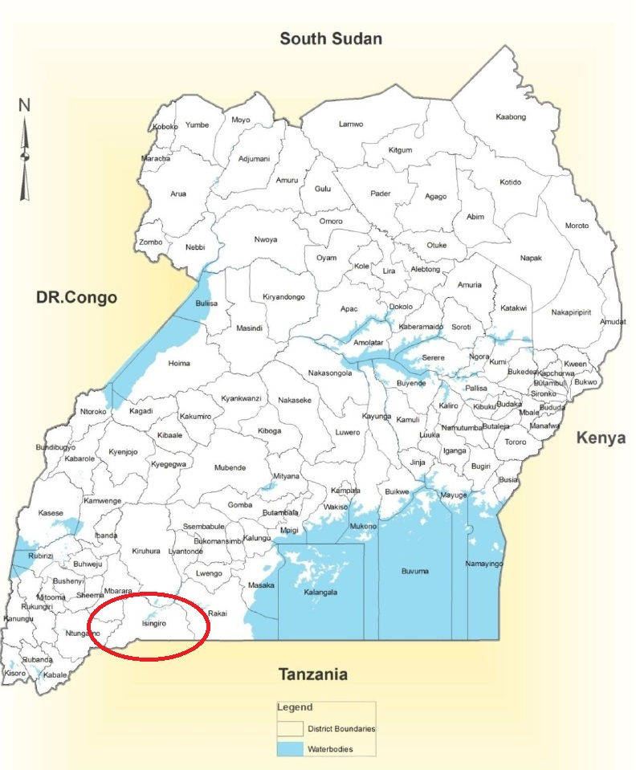

Appendix 2 – Summary of Data on Water Supply inisingiro District

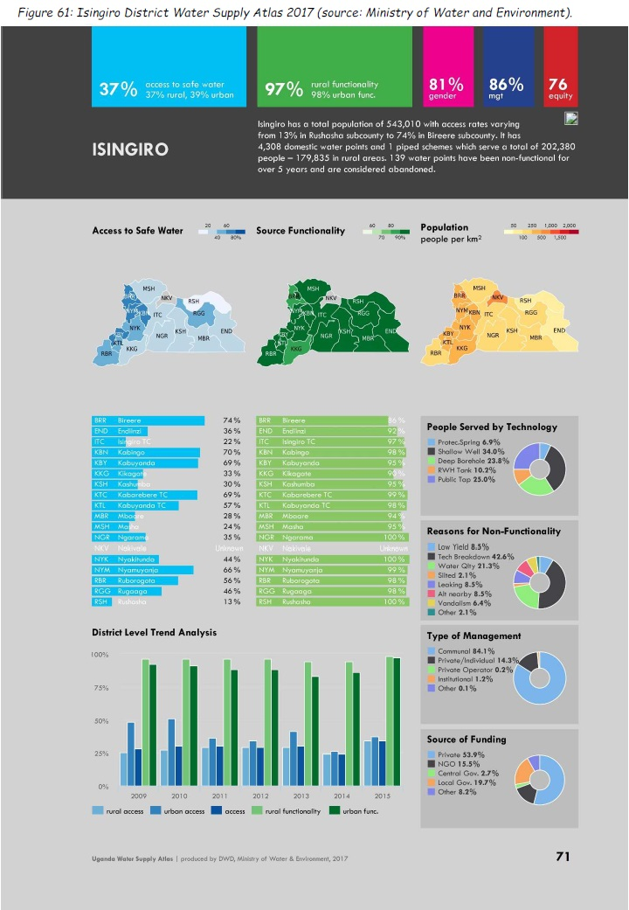

Annex 3: Projects directly implemented by the Ministry ofEauand Environment via the Rural Water Supply Department over the year 2016/2017
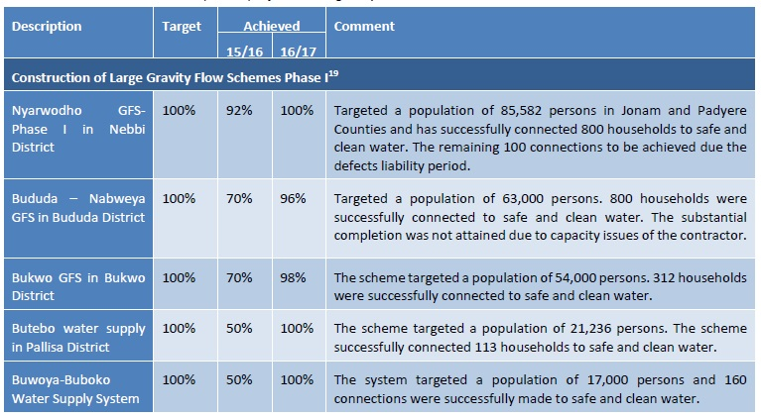
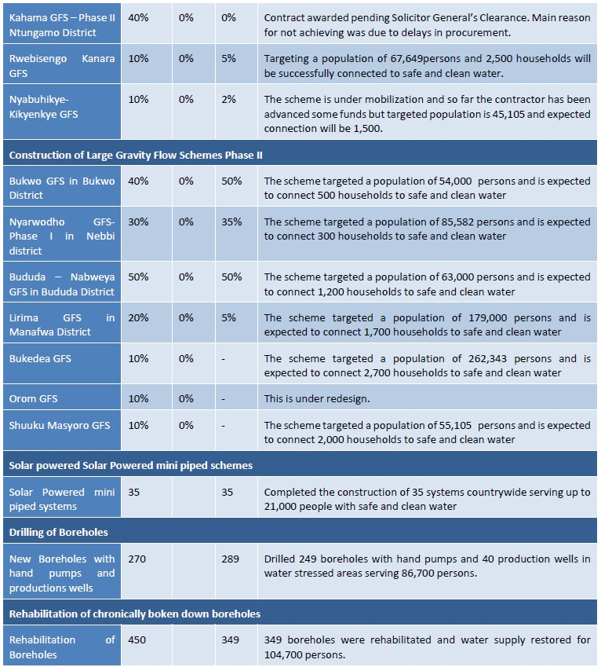

Appendix 4: Evaluation Terms of Reference

Technical diligence

- Validation of the "willingness to pay" study in rural areas;
- Launch of the "willingness to pay" study in refugee camps with UNHCR;
- Launch of the study on(i) the design of the AEP works in the two refugee camps & the modalities of structuring the non-collective sanitation sector in the district;
- Deepening the capacity building program proposed by MWE for the SWUA operator;
- Joint drafting with the MWEof the reference data of the Project Management Assistance.

Organizational diligence

- Finalization of the composition of the various bodies supervising the project, as well as of the various commissions (invitation to tender, etc.) and their meeting arrangements.

